Adam Maher

Bailey Popp

Matthew Teweleit

Phase 1

**Question 1:**

The major advantage to having the gravity constant placed into a struct which is then passed into multiple functions, is that if the gravity constant needed to be changed it would only have to be changed in one place. For instance, if we were going to run these scripts and functions as if rover were on earth, we would only have to change the 3.72 to a 9.81 in the structure. The new value would immediately replace the old value when the field is called within a script or function. This is the most convenient way to define and use the gravitational constant within the codes used for the rover, so we would not have done that any differently.

**Question 2:**

If we call F_gravity using a terrain slope of 110 degrees, an error occurs. The error reads “All values of terrain_angle must be between -75 and +75 degrees.” The error occurring is desirable behavior because the terrain slope is greater than 75 degrees, and our code was written intending to display an error if that slope angle is not in between -75 and 75 degrees.

**Question 3:**

As omega approaches negative infinity, the power increases at a linear rate. However, this is not physically true, so we are going to rely on positive values of omega to determine the maximum power. The maximum power is 161.4963 which occurs at a motor shaft speed of 1.9091 radians/second.

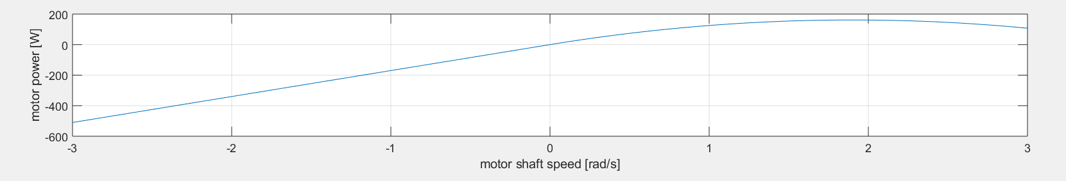

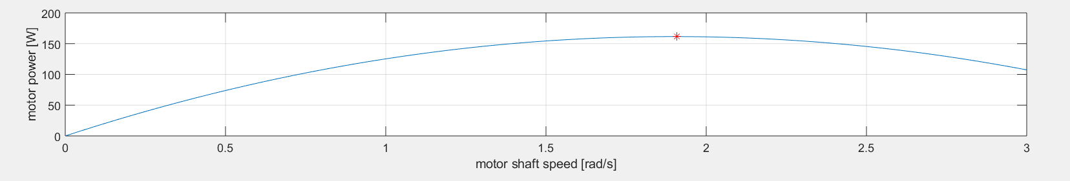

**Question 4:**

The power output of the drive system in the motor and the speed reducer are the same. The power for the motor and the speed reducer are calculated using the same equation of $τ*Ω$ because the gear ratio in the speed reducer equation cancels out. This can be seen in the graphs below, the only difference is seen on the x-axis as the motor is plotted using omega values and the speed reducer is plotted using omega-out values.

**Figure 1:** Power vs Speed Graph of Motor

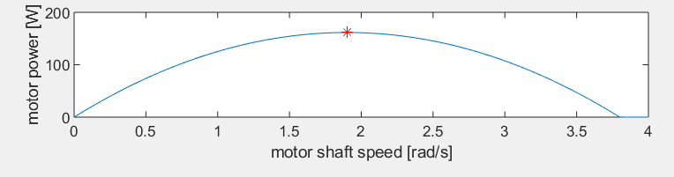

**Figure 2:** Power vs Speed Graph of Speed Reducer

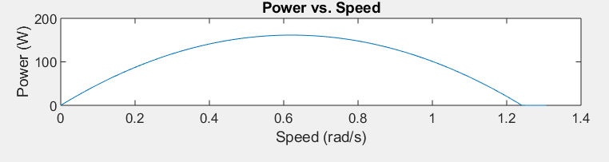

**Question 5:**

According to *Figure 3* the slope decreases at an almost linear rate as the velocity max increases. This does make physical sense because if the rover were going up an incline, the velocity max would be smaller than if the rover were travelling on flat ground. If the rover were on an incline and began to decrease in slope or go down the incline, the velocity max would increase as the figure shows. The slope will retard the speed of Marvin at a linear rate.

**Figure 3:** Slope vs. Velocity Max

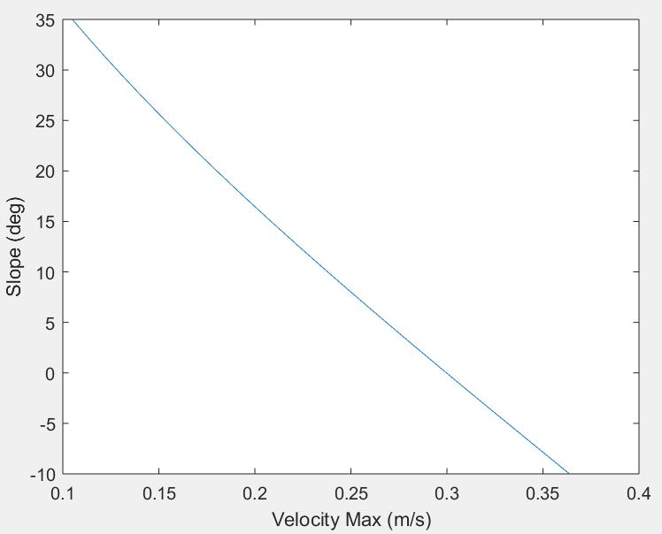

**Question 6:**

As seen in *Figure 4*, the coefficient of rolling resistance (Crr) decreases linearly as the velocity max increases. This does not make physical sense because the coefficient of rolling resistance will actually increase parabolically as the velocity increases. Although the values of the coefficient of rolling resistance will vary for different surfaces, the coefficient should increase as velocity increases regardless of the surface the rover is on. There is going to be greater rolling resistance at higher speeds but the relationship between the coefficient and the velocity would be parabolic instead of linear.

**Figure 4:** CRR vs Velocity Max

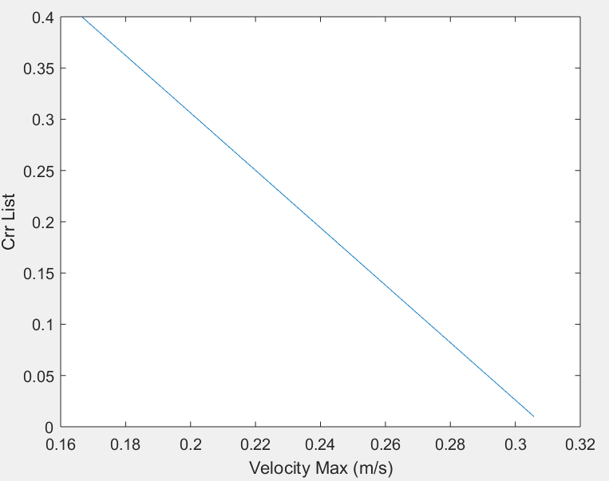

**Question 7:**

In *Figure 5*, the velocity max is plotted on the z-axis, the coefficient of rolling resistance is plotted on the x-axis, and the slope is plotted on the y-axis. This graph shows that as the velocity max increases, the retarding forces will also increase. *Figure 5* shows that the terrain slope is the dominant fact in how fast the rover can travel. This graph shows that it is appropriate to operate the rover on surfaces with small terrain slopes or on decreasing slopes as the velocity max is highest in those conditions. This can be seen on the graph as the velocity max is clearly at its lowest when the terrain slope is at its highest, close to 40 degrees.

**Figure 5:** Crr and Slope vs. Speed

